32-bit ASN

🌐 What Is 32-bit ASN?
# Source: AI Source: Provided by: [Data Path: Persons Table -> ID Column: 1, Name_En Column: Motasem Essam] -> From: [ChatGPT] on [1/16/2026]
A 32-bit ASN (Autonomous System Number) is a unique 32-bit identifier used in BGP (Border Gateway Protocol) to identify an Autonomous System (AS) — a network or group of networks under a single routing policy.
It expands the ASN range beyond the original 16-bit limit to allow for over 4 billion unique ASNs.

🧠 Simple Definition:
# Source: AI Source: Provided by: [Data Path: Persons Table -> ID Column: 1, Name_En Column: Motasem Essam] -> From: [ChatGPT] on [1/16/2026]
A 32-bit ASN is a larger version of the traditional ASN, used to uniquely identify a network in global BGP routing.
It supports values from 0 to 4,294,967,295.

🚀 Why 32-bit ASNs Were Introduced
# Source: AI Source: Provided by: [Data Path: Persons Table -> ID Column: 1, Name_En Column: Motasem Essam] -> From: [ChatGPT] on [1/16/2026]
Originally, ASNs were 16-bit, limited to 65,536 values — too few for the modern internet.
- Introduced by RFC 4893
- Fully supported by most modern routers
- Solves ASN exhaustion

📊 ASN Numbering Overview
# Source: AI Source: Provided by: [Data Path: Persons Table -> ID Column: 1, Name_En Column: Motasem Essam] -> From: [ChatGPT] on [1/16/2026]
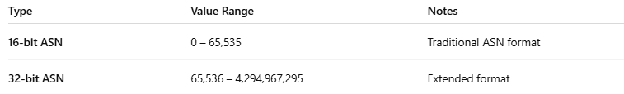

Type | Value Range | Notes
16-bit ASN | 0 – 65,535 | Traditional ASN format
32-bit ASN | 65,536 – 4,294,967,295 | Extended format
Total range for 32-bit ASN = 4,294,967,296 possible ASNs

🧾 ASN Format

🔸 Decimal Format:
# Source: AI Source: Provided by: [Data Path: Persons Table -> ID Column: 1, Name_En Column: Motasem Essam] -> From: [ChatGPT] on [1/16/2026]
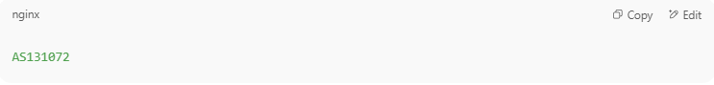
AS131072

🔹 Dotted (ASDOT) Format:
# Source: AI Source: Provided by: [Data Path: Persons Table -> ID Column: 1, Name_En Column: Motasem Essam] -> From: [ChatGPT] on [1/16/2026]
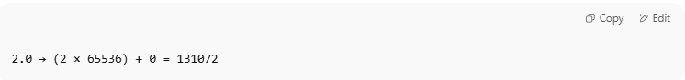
2.0 → (2 × 65536) + 0 = 131072

Format: high-order. Low-order
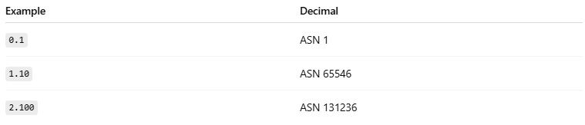
Example | Decimal
0.1 | ASN 1
1.10 | ASN 65546
2.100 | ASN 131236

✅ Advantages of 32-bit ASN
# Source: AI Source: Provided by: [Data Path: Persons Table -> ID Column: 1, Name_En Column: Motasem Essam] -> From: [ChatGPT] on [1/16/2026]
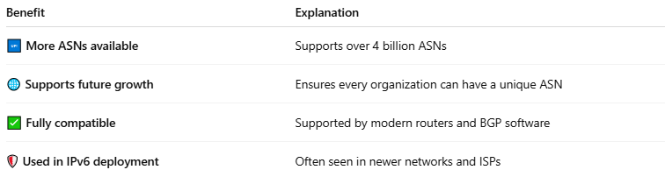

Benefit | Explanation
🆙 More ASNs available | Supports over 4 billion ASNs
🌐 Supports future growth | Ensures every organization can have a unique ASN
✅ Fully compatible | Supported by modern routers and BGP software
🛡️ Used in IPv6 deployment | Often seen in newer networks and ISPs

⚠️ Compatibility Notes
# Source: AI Source: Provided by: [Data Path: Persons Table -> ID Column: 1, Name_En Column: Motasem Essam] -> From: [ChatGPT] on [1/16/2026]
Older devices and software may not recognize 32-bit ASNs if not updated.
Today, 32-bit ASN support is standard in most BGP implementations (Cisco, Juniper, Mikrotik, etc.).

✅ Summary
# Source: AI Source: Provided by: [Data Path: Persons Table -> ID Column: 1, Name_En Column: Motasem Essam] -> From: [ChatGPT] on [1/16/2026]
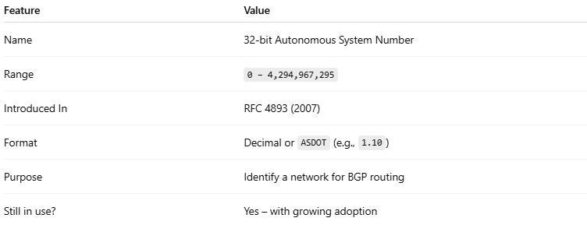

Feature | Value
Name | 32-bit Autonomous System Number
Range | 0 – 4,294,967,295
Introduced In | RFC 4893 (2007)
Format | Decimal or ASDOT (e.g., 1.10)
Purpose | Identify a network for BGP routing
Still in use? | Yes – with growing adoption

